**Stage 2 Chemistry**

**Investigation Folio: Practical – Galvanic Cell**

**Name:** YY  
**Names of Partner:** ZZ

**Part A**

**Investigation Design Proposal:**

**Purpose of Experiment:**To determine the effect of concentration of reactants on the current produced by a galvanic cell.

**Investigation**

Designs a considered and generally clear chemistry investigation.

**Hypothesis:**The greater the concentration of solution in the two half cells reacting with the two metals to produce current, the greater the flow of current will be produced from the galvanic cell.

**Independent Variable:**Concentration of both reactants (Zn2+ and Cu2+).

**How the Independent Variable is changed:**Changed by diluting the 1 mol L-1 (Zn2+ and Cu2+) solution supplied with distilled water, while keeping a constant volume.

**Dependent Variable:**Current flow produced by the galvanic cell.

**How the Dependent Variable is Measured:**Using a multimeter, set on 2V (or lower depending on the current produced by the cell).

**Other factors held Constant in the Experiment:**

**Application**

Uses appropriate chemical terms, conventions, and formulae effectively in this context.

* Electrodes (metal strips of Zn and Cu)
* Electrolytes (both sulfate solutions)
* Volume of solutions used in the galvanic cell
* Length of saltbridge
* Saltbridge solution (0.1 M KCl solution)
* Surface area of electrode dipping into the electrolyte solutions.

**Procedure:**

1. Use 2x 50 mL beakers to make up the following half cells, fill with 25 mL 1M zinc sulfate and 1M copper sulfate solution in each beaker.
2. Use one 50 mL beaker, fill with 30 mL of 0.1M potassium chloride.
3. Soak filter paper strip in the potassium chloride (Keep the salt bridge same length for each repeated experiment).
4. Place zinc metal into the 25 mL zinc sulfate and the copper metal into 25 mL of copper sulfate in the two 50 mL beakers.
5. Connect the two half cells using the soaked filter paper strip (salt bridge).
6. Complete the circuit using wires and connected to the digital voltmeter and record voltage reading.
7. Discard used salt bridge and half cell contents, rinse and wash half cells (50 mL beakers) to be used.
8. Repeat steps 1-7 using diluted copper and zinc solution each time diluting solution to 2x, 4x, 6x and 8x dilution.

**Part B**

**Investigation**

Obtains, records, and displays findings of investigations using appropriate conventions and formats mostly accurately and effectively. This is indicated through:

* use of significant figures inconsistently
* only one trial recorded (further trials allows more logical and relevant predictions to be made).

Table of Values 1.0

|  |  |
| --- | --- |
| **Concentration (mol/L)** | **Current Flow (Volts)** |
| 0.125 | 1.09 |
| 0.167 | 1.097 |
| 0.25 | 1.11 |
| 0.5 | 1.122 |
| 1 | 1.143 |

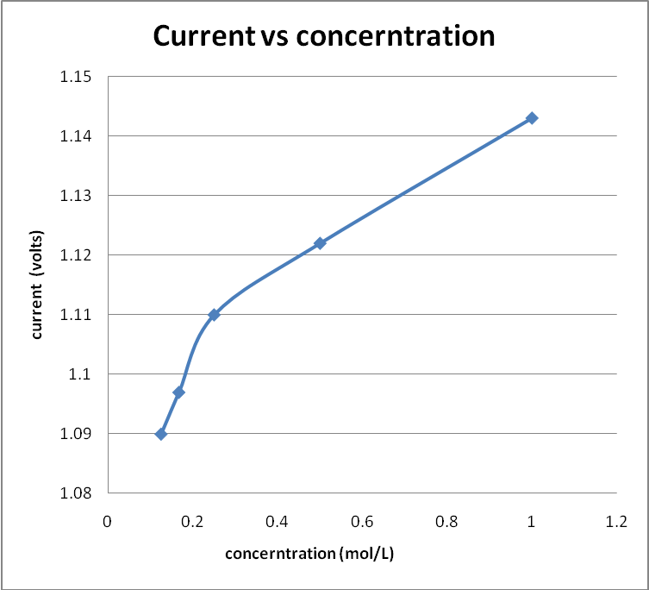

**Investigation**

Obtains, records, and displays findings of investigations using appropriate conventions and formats mostly accurately and effectively. This is displayed through:

* scale of vertical axis exaggerating the supposed relationship (use of a line of best fit would have been more appropriate to show the relationship).

**Random Errors:**

Not enough solution for the experiments, miscalculated quantity needed for the experiment, could afffect the precision and accuracy of the results.

Not measuring volumes at eye level (angle of paralllax) will affect the accuracy of results due to the wrong factor of dilution.

**Systematic Errors:**

Voltmeter not properly calibrated resulting in wrong measurement of direct current voltage reading.

Fixed solution concentration not the same suggested concentration affecting overall data record.

**Analysis and Evaluation**

Evaluates some procedures in chemistry and suggests some improvements that are generally appropriate.

The importance of repeating the experiment for the number of samples in the experiment is to reduce the amount of error in the experiment and to make the the experimental measuring more accurate and precise.

Due to exposure of random and systematic errors the accuracy of the results may vary from the actual measurements of concentration and current, meaning that the recorded data was not accurate. The precision of the results did vary, there were points below the line of best fit suggesting random error. The experiment was not very precise, repeats of the experiment could improve this problem.

A large quantity of undiluted solution could have improved the overall experiments by repeats of the same experiment, as one of the test samples could have been compared with other samples of the same test to improve the accuracy and precision of results.

Keeping the salt bridge at the same length for each experiment could have improved the results from each testing, as wet equipment could have had an effect on the concentration level of the different experiments creating errors within the experiment.

The experiment showed that an increased concentration did increase the amount of current flowing through the circuit. This verifies that the hypothesis was valid for the experiment. Although taking into acocunt that there is not evidence to suggest an accurate relationship between the concentration and flow of current.

**Analysis and Evaluation**

Attempts to formulate a conclusion.

This experiment is a good example of how redox reactions work and how you can increase or slow down a reaction.

Two pictures of the experimental set-up followed (Labeled Figure 1 and Figure 2)

**Investigation**

Use of digital photographs can show evidence of ‘manipulating apparatus and technological tools to generally show careful and effective use of safe and ethical investigation procedures’.

Referring to digital images in the report at relevant location can provide evidence of communication skills.

Please note that the pictures are unavailable for this work sample.

**Additional comments on evidence**

The teacher uses observation, supported by questions or discussion with the student during the practical part of the assessment, to assess the student’s ability to:

* use appropriate chemical terms, conventions, formulae, and equations effectively **(Application)**
* use different formats to communicate knowledge and understanding of chemistry with some general effectiveness **(Knowledge and Understanding)**
* on-balance, obtain, record, and display findings of investigations using generally appropriate conventions and formats with some errors but generally accurately and effectively. **(Investigation)**

Performance Standards for Stage 2 Chemistry

|  | Investigation | Analysis and Evaluation | Application | Knowledge and Understanding |
| --- | --- | --- | --- | --- |
| A | Designs logical, coherent, and detailed chemistry investigations.  Critically and logically selects and consistently and appropriately acknowledges information about chemistry and issues in chemistry from a range of sources.  Manipulates apparatus and technological tools carefully and highly effectively to implement well-organised safe and ethical investigation procedures.  Obtains, records, and displays findings of investigations using appropriate conventions and formats accurately and highly effectively. | Critically and systematically analyses data and their connections with concepts to formulate logical and perceptive conclusions and make relevant predictions.  Critically and logically evaluates procedures and suggests a range of appropriate improvements. | Applies chemistry concepts and evidence from investigations to suggest solutions to complex problems in new and familiar contexts.  Uses appropriate chemical terms, conventions, formulae, and equations highly effectively.  Demonstrates initiative in applying constructive and focused individual and collaborative work skills. | Consistently demonstrates a deep and broad knowledge and understanding of a range of chemistry concepts.  Uses knowledge of chemistry perceptively and logically to understand and explain social or environmental issues.  Uses a variety of formats to communicate knowledge and understanding of chemistry coherently and highly effectively. |
| B | Designs well-considered and clear chemistry investigations.  Logically selects and appropriately acknowledges information about chemistry and issues in chemistry from different sources.  Manipulates apparatus and technological tools carefully and mostly effectively to implement organised safe and ethical investigation procedures.  Obtains, records, and displays findings of investigations using appropriate conventions and formats mostly accurately and effectively. | Clearly and logically analyses data and their connections with concepts to formulate consistent conclusions and make mostly relevant predictions.  Logically evaluates procedures and suggests some appropriate improvements. | Applies chemistry concepts and evidence from investigations to suggest solutions to problems in new and familiar contexts.  Uses appropriate chemical terms, conventions, formulae, and equations effectively.  Applies mostly constructive and focused individual and collaborative work skills. | Demonstrates some depth and breadth of knowledge and understanding of a range of chemistry concepts.  Uses knowledge of chemistry logically to understand and explain social or environmental issues.  Uses a variety of formats to communicate knowledge and understanding of chemistry coherently and effectively. |
| C | Designs considered and generally clear chemistry investigations.  Selects with some focus, and mostly appropriately acknowledges, information about chemistry and issues in chemistry from different sources.  Manipulates apparatus and technological tools generally carefully and effectively to implement and ethical investigation procedures.  Obtains, records, and displays findings of investigations using generally appropriate conventions and formats with some errors but generally accurately and effectively. | Analyses data and their connections with concepts to formulate generally appropriate conclusions and make simple predictions with some relevance.  Evaluates some procedures in chemistry and suggests some improvements that are generally appropriate. | Applies chemistry concepts and evidence from investigations to suggest some solutions to basic problems in new or familiar contexts.  Uses generally appropriate chemical terms, conventions, formulae, and equations with some general effectiveness.  Applies generally constructive individual and collaborative work skills. | Demonstrates knowledge and understanding of a general range of chemistry concepts.  Uses knowledge of chemistry with some logic to understand and explain one or more social or environmental issues.  Uses different formats to communicate knowledge and understanding of chemistry with some general effectiveness. |
| D | Prepares the outline of one or more chemistry investigations.  Selects and may partly acknowledge one or more sources of information about chemistry or an issue in chemistry.  Uses apparatus and technological tools with inconsistent care and effectiveness and attempts to implement safe and ethical investigation procedures.  Obtains, records, and displays findings of investigations using conventions and formats inconsistently, with occasional accuracy and effectiveness. | Describes basic connections between some data and concepts and attempts to formulate a conclusion and make a simple prediction that may be relevant.  For some procedures, identifies improvements that may be made. | Applies some evidence to describe some basic problems and identify one or more simple solutions, in familiar contexts.  Attempts to use some chemical terms, conventions, formulae, and equations that may be appropriate.  Attempts individual work inconsistently, and contributes superficially to aspects of collaborative work. | Demonstrates some basic knowledge and partial understanding of chemistry concepts.  Identifies and explains some chemistry information that is relevant to one or more social or environmental issues.  Communicates basic information to others using one or more formats. |
| E | Identifies a simple procedure for a chemistry investigation.  Identifies a source of information about chemistry or an issue in chemistry.  Attempts to use apparatus and technological tools with limited effectiveness or attention to safe or ethical work practices.  Attempts to record and display some descriptive information about an investigation, with limited accuracy or effectiveness. | Attempts to connect data with concepts, formulate a conclusion and make a prediction.  Acknowledges the need for improvements in one or more procedures. | Identifies a basic problem and attempts to identify a solution in a familiar context.  Identifies some chemical terms or formulae.  Shows emerging skills in individual and collaborative work. | Demonstrates some limited recognition and awareness of chemistry concepts.  Shows an emerging understanding that some chemistry information is relevant to social or environmental issues.  Attempts to communicate information about chemistry. |